# Lab Class Journal

## Introduction

This lab journal is used for helping me do revision. After each week, I write down this journal to help summaries the knowledge I learnt on class.

## Chapters

Lab Class Journal 1

Introduction 1

Chapters 2

Week1 3

the basic network understanding 3

ISP(Internet Services Provider) (Ross, 2022) 3

Internet and internet 3

Network Devices (Melnick, 2019) 3

OSI & TCP/IP Models (谢希仁, 2016) 5

Number Systems in IT 6

Week2 7

Network Addressing 7

Addressing Rules 8

Intro to Project Management 9

Week3 10

Week4 10

Reference 10

## Week1

During this week, I had the basic network understanding. To know what is the Internet, and have a clear understand of internet devices. In addition, how the Internet formed and be connected to every one and how the Internet services us.

### the basic network understanding

Well, Internet is a worldwide computer network which is connected all the word more than 2 billion devices network. The connected Internet devices not only are computer but also for those devices which have ability to connect Internet. Such as, smart-phone. smart-watch. smart air-condition, and even a light(controlled by a micro-cpu and connected to Internet ) etc.

### ISP(Internet Services Provider) (Ross, 2022)

Most of our used network are provided by ISP(Internet services provider). Such as, Now I am at university and my smart phone connected with the wireless network（WIFI IEEE 802.11b）by wireless router. By now , the school provides the connection of network for me. So the school can be called as ISP; and, the network in school is provided by other larger ISP provider such city ISP. Then the network in the city is provided by national ISP. All the national ISP connected together formed the Internet.

### Internet and internet

Be mentioned, internet is not same as Internet. Internet means small area network such as local network, home network and school network etc. But the Internet means large or worldwide network.

### Network Devices (Melnick, 2019)

There are a lot of network devices such as Repeater, Hub, Bridge, Switch, Routers

#### Repeater

A repeater operates at the physical layer. Its job is to regenerate the signal over the same 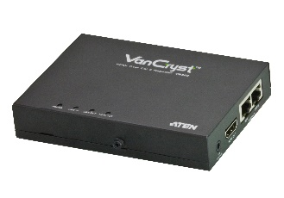network before the signal becomes too weak or corrupted to extend the length to which the signal can be transmitted over the same network. An important point to be noted about repeaters is that t hey do not amplify the signal. When the signal becomes weak, they copy it bit by bit and regenerate it at its star topology connectors connecting if original strength. It is a 2-port device.

#### Hub | What is the hub - javatpointHub

A hub is a basically multi-port repeater. A hub connects multiple wires coming from different branches, for example, the connector in star topology which connects different stations. Hubs cannot filter data, so data packets are sent to all connected devices. In other words, the collision domain of all hosts connected through Hub remains one. Also, they do not have the intelligence to find out the best path for data packets which leads to inefficiencies and wastage.

#### WHAT IS BRIDGE IN NETWORKING| Features of Bridge in computer network with live example | 2017Bridge

A bridge operates at the data link layer. A bridge is a repeater, with add on the functionality of filtering content by reading the MAC addresses of the source and destination. It is also used for interconnecting two LANs working on the same protocol. It has a single input and single output port, thus making it a 2 port device.

#### Switch

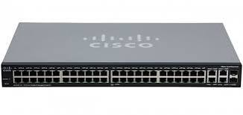A switch is a multiport bridge with a buffer and a design that can boost its efficiency(a large number of ports imply less traffic) and performance. A switch is a data link layer device. The switch can perform error checking before forwarding data, which makes it very efficient as it does not forward packets that have errors and forward good packets selectively to the correct port only. In other words, the switch divides the collision domain of hosts, but the broadcast domain remains the same.

#### Routers, Switches, And Hubs - Understanding Your Network Components | Jones ITRouters Routers help transmit packets to their destinations by charting a path through the sea of interconnected networking devices using different network topologies. Routers are intelligent devices, and they store information about the networks they’re connected to.

### OSI & TCP/IP Models (谢希仁, 2016)

OSI & TCP/IP Models are abstract model. Which is not really in the network, just exist there logically. There are seven layers inside OSI model, from the top to bottom there are Application layer, presentation layer, session layer, transport layer, network layer, data linking layer and the physical layer.

To compare with the TCP/IP Model. TCP/IP model only has 4 layers, presentation layer

transport layer, network layer and network interface layer.

|  |  |
| --- | --- |
| OSI Model | TCP/IP model |
| Application | Application |
| presentation |
| Session |
| Transport | Transport |
| Network | Network |
| Data linking | Network interface |
| physical layer |

For TCP/IP model, the application layer is including Application, Presentation, Session

And the network is including Data Linking and Physical layer

#### Application

Application layer is the highest layer in OSI model. It’s main task is running special network application though some interactions between the same layer application thread. Such as DNS , HTTP protocol and SMTP protocol(for e-mail).

#### Transport

The main mission in transport layer is in charge of the common data transferring service in the thread of different hosts. Such as TCP protocol（Transmission Control protocol）and UDP protocol(User Datagram protocol)

#### Network

Network layer provide communication service to those different hosts on packet switching. When a host sending data to others， this layer package those data created in transport layer to package or grouping then transfer.

#### Data Link

The data-link layer is responsible for transferring messages (or frame) from a given node to all other nodes in the CAN network. This layer handles bit stuffing and checksums for error handling, and after sending a message, waits for acknowledgment from the receivers.

#### Psychical

The main function of the physical layer is to convert data into corresponding binary codes

### Number Systems in IT

Well, the computer can only recognize 0 and 1. Which called machine language, binary . And decimal system, octonary number system, and Hex

#### Convert decimal to binary

One of the methods to convert decimal to binary is by dividing the given decimal number recursively by 2. Then, the remainders are noted down till we get 0 as the final quotient. After this step, these remainders are written in reverse order to get the binary value of the given decimal number

#### Convert binary to decimal

11010100

|  |  |  |  |  |  |  |  |
| --- | --- | --- | --- | --- | --- | --- | --- |
| 2^7 | 2^6 | 2^5 | 2^4 | 2^3 | 2^2 | 2^1 | 2^0 |
| 1 | 1 | 0 | 1 | 0 | 1 | 0 | 0 |

2 ^ 7 + 2 ^ 6 + 2 ^4 + 2 ^2 = 212

The same principle to others

## Week2

### Network Addressing

#### Bus Topology

Bus topology is a type of network topology in which all devices on the network are connected to a common communication pathway, known as a "bus". In a bus topology, a single cable, also known as a trunk or backbone, connects all the devices on the network. Data travels along the bus from one end to the other, and each device on the network receives every transmission, but only the intended recipient processes the data.

The advantages of bus topology are easy to install and maintain (All devices are connected with one backbone), Cost-effective (requires less cable), efficient(when send data, all devices will receive one transmission)

Conversely, the disadvantage is very deadly. If the backbone line is broken，all the network will lost connection

#### Star Topology

Star topology is a type of network topology in which all devices on the network are connected to a central hub or switch. In a star topology, each device has a dedicated point-to-point connection to the central, and all communication between devices takes place through the central.

A Concentrator can be:

Hub – Regenerates Bit to all devices.

Switch – Regenerates Frame to destination device

Router – Forwards Packet according to IP address

#### Ring Topology

Ring topology is a type of network topology in which all devices on the network are connected to each other in a closed loop or ring. In a ring topology, data travels in one direction around the ring, and each device on the network acts as a repeater to boost and forward the signal to the next device.

#### Fully Meshed Topology

Fully Meshed Topology means all devices in this network are connected to others. This is the fastest, the safest topology. Conversely, this kind of topology is also difficult to administer and cost highest. If the number of device is low, it is fine. But if the number is high that will cost a lot of money to build as each one should connect to others.

### Addressing Rules

#### The address of layer2 and layer3

Layer 2 and Layer 3 addresses are both used in computer networks to identify devices and facilitate communication between them. However, they operate at different layers of the networking stack and serve different purposes.

For layer 2 (Data linking layer) also known as MAC (Media Access Control) addresses. Which assigned by the provider company. And the MAC address is unique to each devices. When a message thought the switch . the switch will according to the MAC address to query the routing table to find where is the destination

For layer 3 (network) address , also known as IP (Internet Protocol) addresses, are used to identify devices on different network segments and facilitate communication between them.

IP addresses are assigned by network administrators and are unique to each device on a network

#### IP address

For Ip address version 4, used 32 bits to store. Which means in total 2 ^ 32 Ip addresses are available.

1111 1111 1111 1111 1111 1111 1111 1111

0000 0000 0000 0000 0000 0000 0000 0000

The range of ip address is from 0.0.0.0 to 255.255.255.255

And the Ip address is hierarchical.

|  |  |  |  |  |  |
| --- | --- | --- | --- | --- | --- |
| **Class** | **First Bit(s)** | **Network Bits** | **Host Bits** | **Available Address Ranges** | **Max Hosts** |
| A | 0 | 8 | 24 | 1.0.0.0 to 126.0.0.0 | 16,777,214 |
| B | 10 | 16 | 16 | 128.0.0.0 to 191.255.0.0 | 65,534 |
| C | 110 | 24 | 8 | 192.0.0.0 to 223.255.255.0 | 254 |

#### Subnet mask

Subnetting enables the hierarchy. Which is used determine the Network, Sub-Network and Host portions of the IP address

Subnet mask 255.255.255.255

1111 1111 ,1111 1111, 1111 1111, 1111 1111

Here is an example of subnet mask. Below is a screen-shot of my IP address.

In windows, we can use command of ipconfig to check the IP config

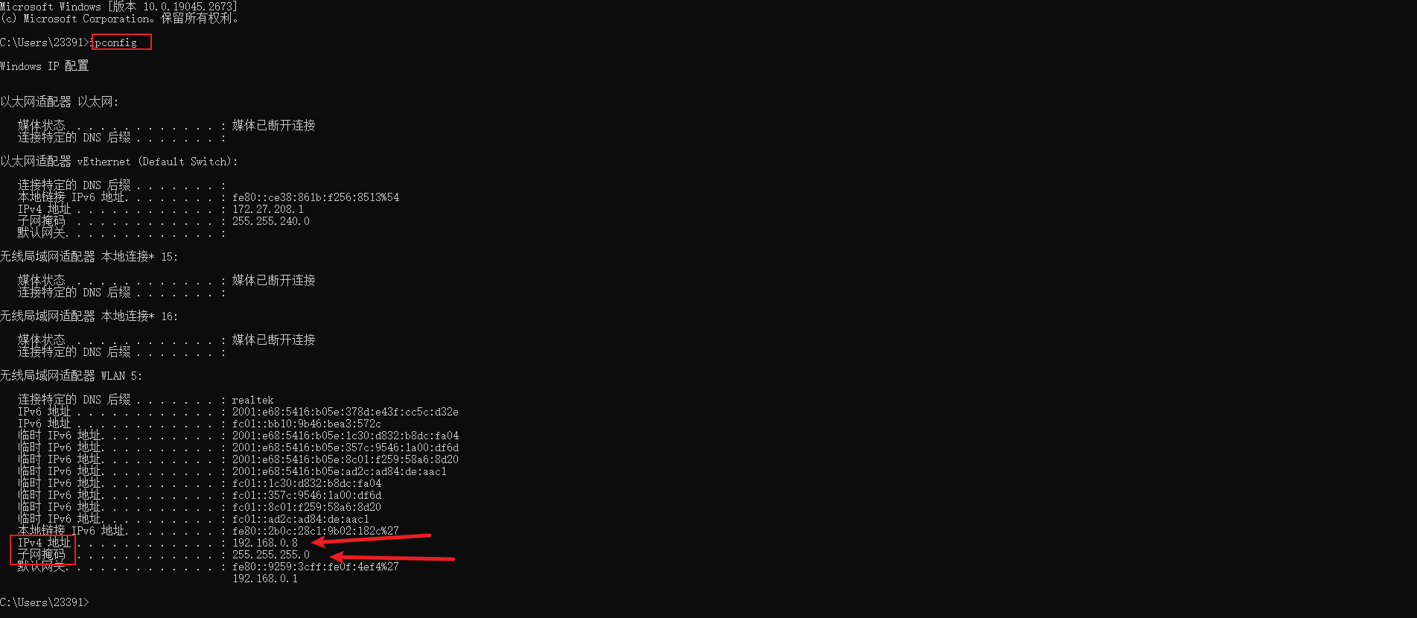

We can clear seen that my IP address is 192.168.0.8 and the subnet mask is 255.255.255.0 like below

1111 1111 ,1111 1111, 1111 1111, 0000 0000

And we can according to the table known that this computer is in Class C.

So, we can have 2 ^ (32-24) = 256 subnets.

And we have 2 ^(the number of 0) hosts = 256

But

### Project Management

## Week3

## Week4

# Reference

Melnick, J. (2019, January 8). *Network Devices Explained*. Retrieved from netwrix: https://blog.netwrix.com/2019/01/08/network-devices-explained/

Ross, J. F. (2022). *A Top-down Approach Computer network (计算机网路- 自顶向下方法).* 北京市: 机械工业出版社（China machine press）.

谢希仁. (2016). *计算机网络.* 北京市: 电子工业出版社.